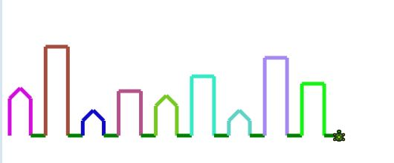

1. have the tortoise start in the bottom left corner

2. draw a house of height 100 with grass after it. This shape: |**|_

3. extract the piece of code that draws the house into a method. Draw 10 houses.

4. Change the method to take int height as a parameter. Draw 9 houses of different heights

5. Make the method take a String instead of a height.

“small” 60

“medium” 120

“large” 250

6. Make the method take a color as well as a height. The houses are drawn in that color.

[optional] Set the scene to night time by setting the background to black using Tortoise.getBackgroundWindow().setColor

7. Give the houses peaked roofs

8. Extract that roof code into a method “drawPointyRoof” and create a new method: “drawFlatRoof”.

9. make large houses have flat rooves